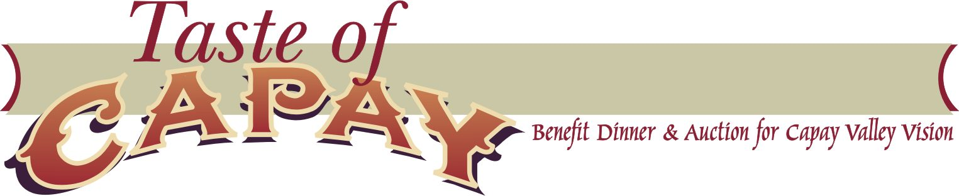

**Capay Valley Vision Accomplishments**

* Raised over $14,000 from the 2018 Taste of Capay to support improvements to local community parks. Currently coordinating with the Esparto Community Services District to replace the playground rubber chips with natural wood chips. This is a long-desired change requested by parents in the community. Additionally, other improvements are also being evaluated at Nichols park in Guinda.
* Ongoing effort and outreach to other local non-profit organizations for collaboration in the community. Recent focus has been in creating a “Community Hub” resource, both physical and digital.
* Celebrated the opening of the SunRise Pre-School in Esparto. Capay Valley Vision administered the construction phase of this project in 2016. RISE, Inc now manages the program that serves 24 children.
* Completed the Capay Valley Action Plan, a 48 page document funded by the Yolo County Rural Initiative Fund and the Heitman Foundation, that identifies community needs in Agriculture, Agritourism, Communications, Community Advocacy, Community Infrastructure, Economic Development, Education, Housing, Social Services, Recreation, Safety Services, Traffic. This document will be used to secure future grants and for governmental entities to prioritize community benefit projects in the region.
* Contributed the proceeds from the 2017 Taste of Capay to the Western Yolo Recreation and Aquatic Fund. Over $25,000 raised at the event went to the endowment to support the annual operations and maintenance of the Esparto Park and Aquatic Center.
* Participated in the celebration of the Esparto Park and Aquatic Center Groundbreaking and Ribbon Cutting Ceremonies.
* Held a public forum workshop in Esparto to promote Capay Valley Vision's mission, get input on its future direction, and recruit new membership.
* Capay Valley Vision is comprised of a volunteer Board of Directors. The current board members include: Trini Campbell, Gwenael Engelskirchen, Jason Gillham, Giacomo Moris, Paul Muller, Matt Trask, and Sherri Wood. Board meetings are held monthly.